***COMSATS UNIVERSITY***

**WAH CAMPUS**

# Tittle: Formula 1 Case Study

***Submitted By***

|  |  |  |  |
| --- | --- | --- | --- |
| Shayan Babar | M.Arsal | Ali Raza | Saad Rashid |

***Name:***

|  |  |  |  |
| --- | --- | --- | --- |
| Fa19bcs051 | Fa19-BCS-056 | Fa19-BCS-047 | Fa19-BCS-194 |

***Registration No:***

***Class/Section:*** *BSCS/6d*

***Submitted To***

***Teacher Name:*** *Ammara Zamir*

***Date of Submission:*** *27/03/2022*

**Read using Data Frame**

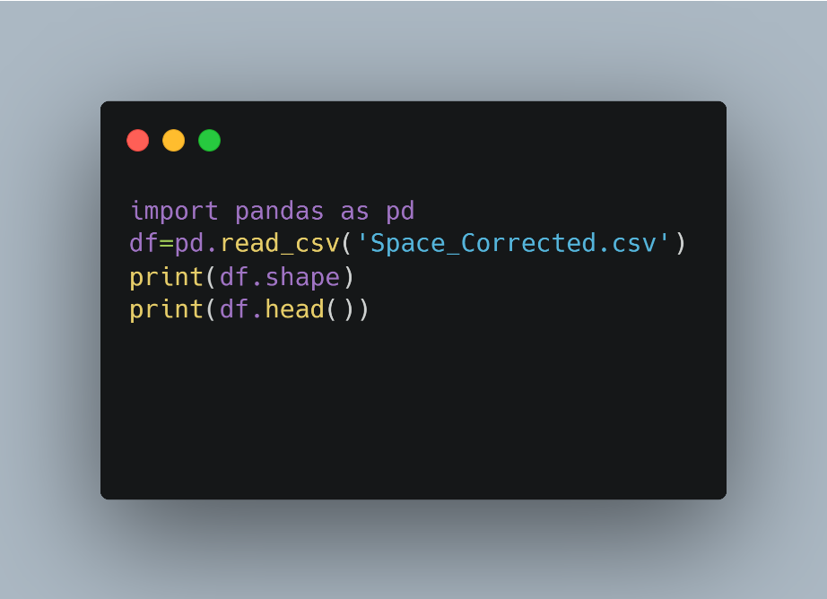

**Assign a particular value to a specific row or a column in a Data Frame.**

**Add new rows and columns in Data Frame.**

New row added

New Column added

**Update or modify a particular value**

**update or modify a particular row or a column.**

Updating column nu#2

**Delete rows and any column as per your understanding.**

Deleting row 1-10

References:

[All Space Missions from 1957 | Kaggle](https://www.kaggle.com/datasets/agirlcoding/all-space-missions-from-1957?resource=download)